Project 4 Results
Question 1: Average Purchase List Price and Sale Price by State
The chart below shows the average purchase list price and sale price across U.S. states. California has the highest average list price of $3,106.62 and sale price of $3,101.48, indicating strong market pricing. Tennessee had an average list price of $2,569.23 and sale price of $2,556.79. The minimal difference between list and sale prices suggests limited discounting and stable pricing across states.
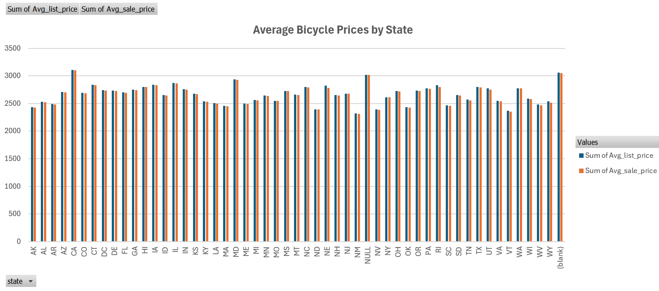
Question 2a: Average Prices by Store
This pivot chart shows that store-level average prices vary greatly. Schanewolf's Cycle Sport had the highest average list price at $6,346.00 and sale price at $6,340.00. Most stores have small price differences between list and sale, indicating that customers generally pay full price. This consistency suggests uniform pricing strategies and minimal promotions across most stores.
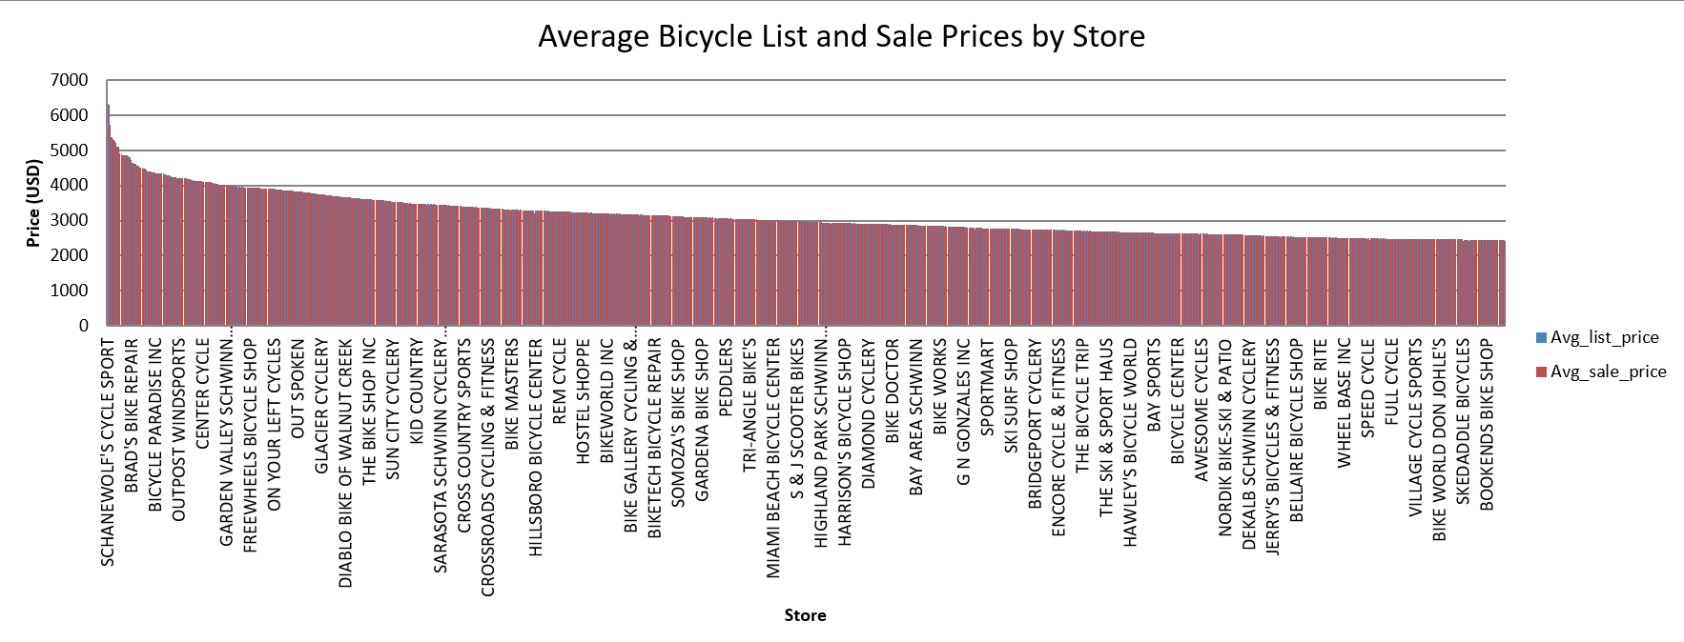
Question 2b: Tennessee Store Analysis
Among stores located in Tennessee:
- 19 stores are above the state average list price
- 18 stores are below the state average list price
The pie chart below illustrates this near-even division. This suggests Tennessee supports a balance between premium and budget pricing strategies across its stores.

Question 2c: Comparison to National Rankings
Compared to the national rankings, Tennessee ranked 34th nationally in average list price. It falls in the middle, not among the most expensive like California, nor the cheapest like New Mexico. This suggests a balanced market that appeals to a range of customers. This balance suggests Tennessee is a competitive, mid-range market that accommodates a wide variety of consumer preferences.
Question 3: Paint Color Popularity
Figure 1: Paint Color Performance by Total Units Sold and Sales Revenue
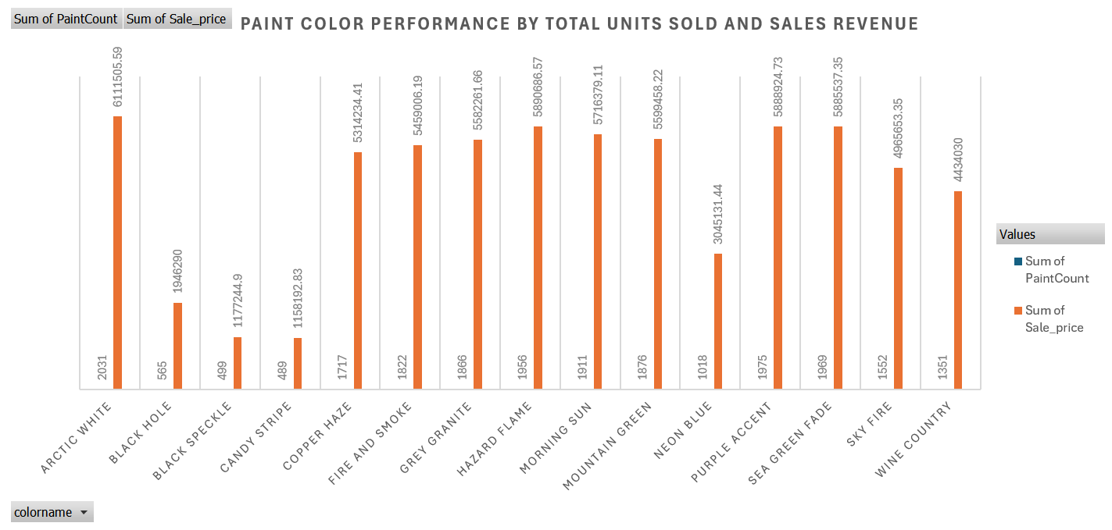
This chart compares paint colors by both units sold and total sales revenue. Arctic White stands out as the clear leader, with over 2,000 units sold and more than $6.1 million in sales. In contrast, Candy Stripe, despite being available, records the lowest performance in both categories. Mid-range performers like Sea Green Fade and Hazard Flame also show strong sales, suggesting secondary demand clusters. This visual confirms the need for focused inventory strategies prioritizing high-performing colors and reevaluating low-demand ones through targeted promotions or regional restrictions.

a. For the Most Popular Paint Color:
Most Popular Paint Color: Arctic White
- Most sold by: Walk-In (1,386 units, $4,251,790)
- Least sold by: Beverly Hills Bike Shop (5 units, $18,640)
b. For the Least-Popular Paint Color:
Least Popular Paint Color: Candy Stripe
- Most sold by: Walk-In (255 units, $572,650)
- Least sold by: Rainbow Cycles (1 unit, $1,200)
c. What Does This Tell You About Marketing?
The difference in popularity between Arctic White and Candy Stripe shows the importance of aligning inventory with customer preferences. Arctic White's high sales indicate strong demand and widespread appeal, making it a safe product to stock in large quantities. On the other hand, Candy Stripe’s minimal sales suggest it is more niche, requiring targeted marketing or being phased out in low-demand regions. These insights can help stores optimize product offerings, reduce overstocking of slow movers, and focus promotional efforts where they’re most likely to increase sales.
Question 4: Most Popular Part Manufacturer
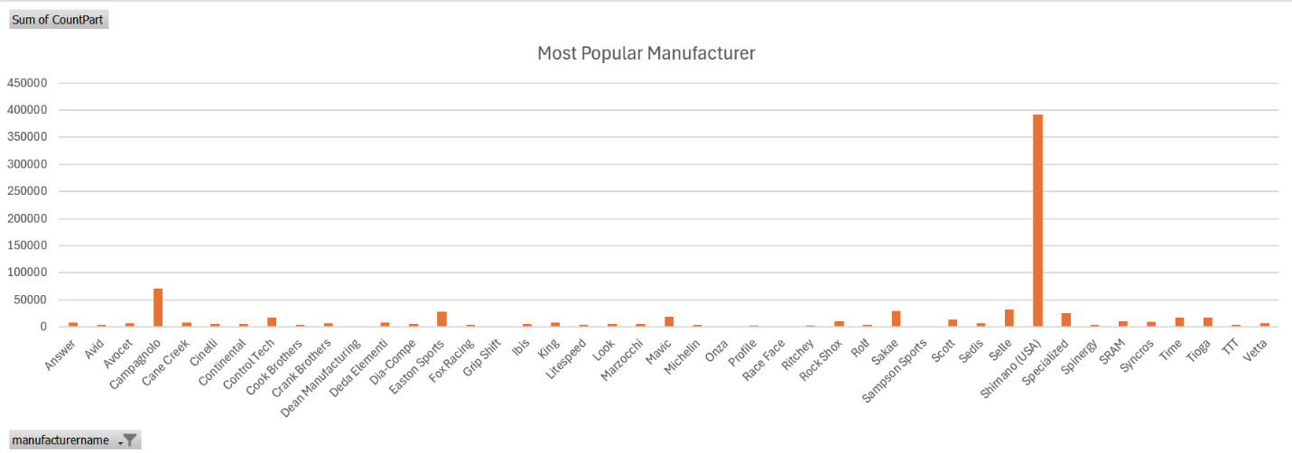
From this chart, Shimano (USA) is the most widely sold part manufacturer by a significant margin, with more than 195,000 parts sold. Other manufacturers such as Campagnolo and Sram follow at much lower volumes.
a. Which States Sell the Most and Least of These Parts?
According to the data, California (CA) had the highest volume of part sales, with 1,089 units sold and $3,260,343.57 in revenue. On the other hand, Delaware (DE) recorded the lowest sales, with just 3 units sold, totaling $8,190.00. This stark contrast shows regional variation in demand, which may relate to cycling popularity, store density, or marketing effectiveness.
b. Which Store (Excluding Walk-In and Direct Sales) Sells the Most of the Most Popular Part?
The top-performing store for Shimano parts, excluding Walk-In and Direct Sales, is Budget Pro Bicycles, with 69 units sold totaling $223,780.00 in revenue. This reflects high demand at that specific location and strong sales performance for Shimano parts. This store achieved the highest volume of Shimano’s Front Derailleur component sales among all traditional retail outlets, indicating its strong product positioning and customer loyalty.
c. How Would This Data Influence Store Decisions?
This data provides valuable insights for store owners. High-performing manufacturers like Shimano should be prioritized in purchasing and merchandising. Stores in regions with high demand should maintain higher inventory levels. Underperforming stores may need to reassess part placement, pricing, or promotional strategies. Additionally, knowing which states or stores lag in part sales can help inform regional marketing or training efforts.

Conclusion
Overall, the data reveals consistent pricing patterns at state and store levels, with Tennessee standing as a balanced, mid-range market. Arctic White and Shimano dominate their respective categories, showing clear consumer preferences. Store owners should leverage these insights to stock efficiently, promote strategically, and respond to regional demand effectively.

